**STANDARDIZATION & NORMALIZATION**

**Name:** Shreyas A B

**Batch Id:** 05012021-10AM

**Topic: STANDARDIZATION & NORMALIZATION**

**Problem Statement:**

Data is one of the most important assets. It is often common that data is stored in distinct systems with different formats and scales. These seemingly small differences in how the data is stored can result in misinterpretations and inconsistencies in your analytics. Inconsistency can make it impossible to deliver reliable information to management for good decision making. We have the preprocessing techniques to make the data uniform. Explore the various techniques to have reliable uniform standard data, you can go through this link:

<https://360digitmg.com/mindmap-data-science>

1. Prepare the dataset by performing the preprocessing techniques, to have the standard scale to data which improves the model predictions .

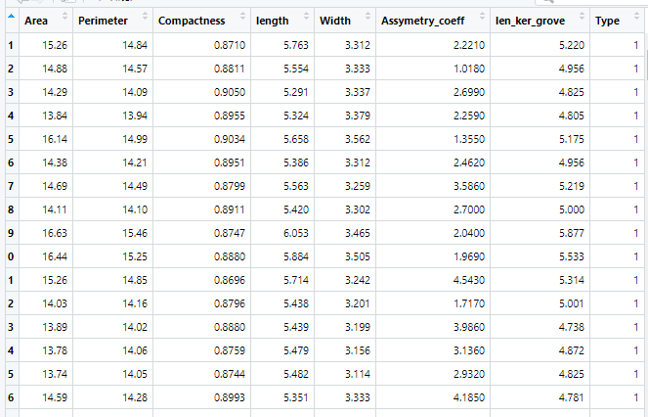

|  |  |  |  |
| --- | --- | --- | --- |
| Name of Feature | Description | Type | Relevance |
| Area | Area of seed | Continuous, Ratio | Provides useful information |
| Perimeter | Perimeter of seed | Continuous, Ratio | Provides useful information |
| Compactness | Compactness of seed | Continuous, Ratio | Provides useful information |
| Length | Length of seed | Continuous, Ratio | Provides useful information |
| Width | Width of seed | Continuous, Ratio | Provides useful information |
| Assymetry_coeff | Asymmetry coefficient of seed | Continuous, Ratio | Provides useful information |
| len_ker_grove | length of kernel groove | Continuous, Ratio | Provides useful information |
| Type | Type | Discrete, Count | Provides useful information |

**Business Objective**:   Objectives of data preprocessing include size reduction of the input space, smoother relationship, data normalization, noise reduction, and features extraction.

**Business Constraint**: Minimize computational time and significant effort.

**Hints:**

For each assignment, the solution should be submitted in the below format

1. Work on each feature to create a data dictionary as displayed in the image displayed below: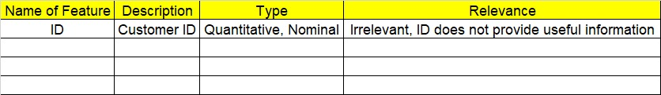
2. Refer to Seeds_data.csv file
3. Research and perform all possible steps for obtaining solution
4. All the codes (executable programs) should execute without errors
5. Code modularization should be followed
6. Each line of code should have comments explaining the logic and why you are using that function